Lecturer : Khurshid Abdul Jabbar
Module Code : CT012-3-3-CSM Computer Systems Management
Handout Date : Week 2
Due Date : Week 12
__________________________________________________________________________________________________

Project Description

The module lecturer shall select a company.

Your assignment is to produce a research report aimed at a mixed readership, in terms of technical and managerial knowledge. You will need to research the company’s Information Systems (IS) and Information Technology (IT) developments in journals, research papers and articles, magazines and websites.

You will need to go beyond your lectures to undertake out this assignment effectively. You should state clearly any assumptions and give references for any information sources you use.

  - Group Work (40%)

This section will consist of 1,500 words, addressing Learning Outcome 2.

Company Strategy
- Describe the company’s background and business model
- Analyse two methods how technology is used to keep its customers and company connected
- Provide two recommendations for improvements based on your findings in item b) above
- Conclusion

Individual Work (60%)

This section will consist of approximately 1,500 words addressing Learning Outcome 3.

Environmental Analysis
Building on the work done in group work
- SWOT is an analytical framework that can help your company face its greatest challenges and find promising new markets. Carry out a SWOT analysis on the company to determine two company weaknesses. Recommend two solutions based on Porter’s Competitive Advantage Strategy to overcome the weaknesses.

- Your company plans to expand to a new overseas market.
  - Study two possible security threats that may occur and recommend solutions to overcome them.
  - Critically examine how IT can be used as a Supply Chain enabler to aid the company in the new market.

- Performance Criteria

Course Learning Outcome | Marks | Criteria
CLO2 | 30 | Team research: In-depth research undertaken with analysis and critical evaluation applicable to case study
CLO2 | 10 | Team Report: Quality documentation adheres to Academic Writing, APA Referencing. No spelling and grammatical mistakes
Group  Sub Total | 40

Course Learning Outcome | Marks | Criteria
CLO3 | 30 | Critical evaluation and analysis of issues
CLO3 | 20 | Proposal of solutions to address issues with original ideas
CLO3 | 10 | Presentation
Individual Sub Total | 60
Total | 100

Marking criteria

Distinction
Demonstrated comprehensive research with detailed evidence. High level of analysis performed, exceptional and thorough knowledge and understanding displayed with regard to application. This includes analysis and evaluation of facts followed by results of evaluation. Documentation presented in a professional manner, following proper sequencing and flow. Displayed evidence of critical appraisal.

Credit
Adequate research conducted with fair detail of evidence presented. Moderate level of understanding, analysis and knowledge displayed. Some level of relevance included in terms of application. Moderate level of analysis and evaluation of facts followed by results comparison. Good level of documentation presented. Some level of reflection was evident in the documentation. Moderate level of critical appraisal.

Pass

Low level research conducted. Some evidence of research displayed. Basic level of understanding and knowledge analysis displayed. Satisfactory level of documentation. No evaluation and analysis of facts, no results comparison performed. Satisfactory or low level of reflection displayed. No level of critical appraisal demonstrated.

Report Guidelines

- Line spacing: 1.5 lines
- Font Size: 12 (except titles and headings)
- Font Type: Times New Roman

- Submission
Details of what is to be submitted:

- The assignment should be submitted in Moodle as two reports: Group (submitted by the Group Leader) and Individual (every student submits his/her part).
- Every group member is required to present their assignment (5 minutes each).
- Submission deadline: Week 12

- Introduction – Aryan – 500

Company Background
Buddhar Air
Services provided by the Company
Organizational Structure
- Business Model -aryan
- Method
Buddha Air, Nepal’s leading domestic airline, uses technology in a variety of ways to keep its customers and company connected. Two notable examples include:
- Mobile App
Buddha Air’s mobile app is a convenient and user-friendly way for customers to book flights, check their flight status, manage their plans. It enhances customer experiences by enabling customers to book and manage their flights, receive real-time flight updates, check-in and boarding, baggage tracking, flight notifications, special offers and offline access to the app. It also includes a travel inspiration section with articles and photos about Nepal and other destinations ​(buddhaair, 2019)​.
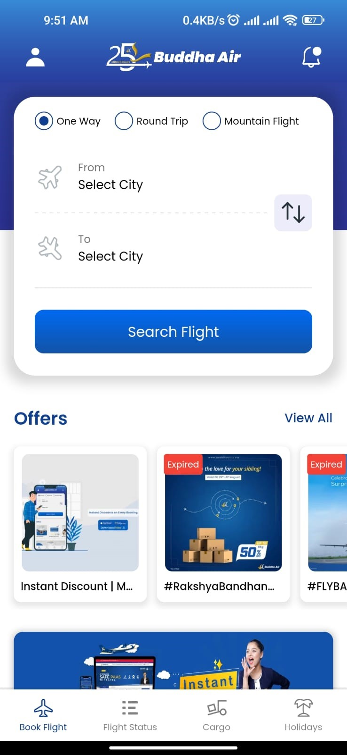
Figure 1: Buddha Air's Mobile App
Here are some of the ways how Buddha Air uses its mobile app to keep its customers and company connected:
- Customers can book and manage app their flights including selecting their preferred seats, adding baggage and checking in for their flights which saves customers time and hassle with a reduction in congestion at the airport plus streamlined operation benefits for the company.
- Real-time updates on flight status including any delays and cancellations help customers to stay informed and plan their travel accordingly.
- Customers can inquire about any questions or concerns using the app and can get prompt and efficient bot assistance, also helping the company to reduce costs by reducing the need for customer service representatives.
- Royal club frequent flyer program members can use the app to track their mileage points, redeem rewards and manage their membership accounts enabling making the most of their membership and enjoy exclusive benefits.
- Articles and photos about Nepal and other destinations on travel inspiration section helps customers to discover new places and to visit and plan their next trip.

- Social Media
Buddha Air is active on a variety of social media platforms, including Facebook, Twitter, Instagram, YouTube, LinkedIn and Pinterest serving engaging content posts that is relevant to keep its customers and company connected. Customers can ask questions, get help with booking flights, and report issues on social media. In addition to this, customers can check the status of their flight, see if there are any delays or cancellations, and get other important information.
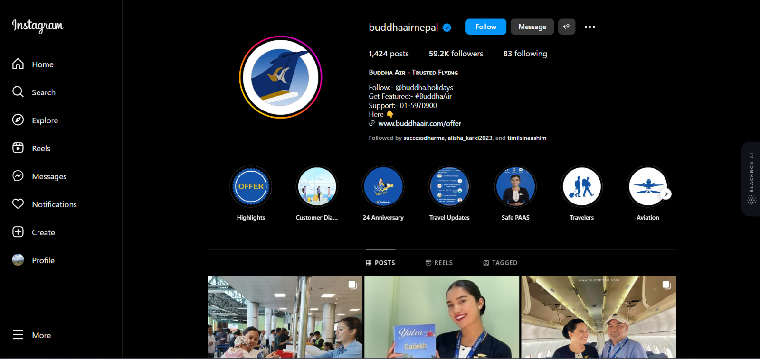
Figure 2: Buddha Air on Instagram
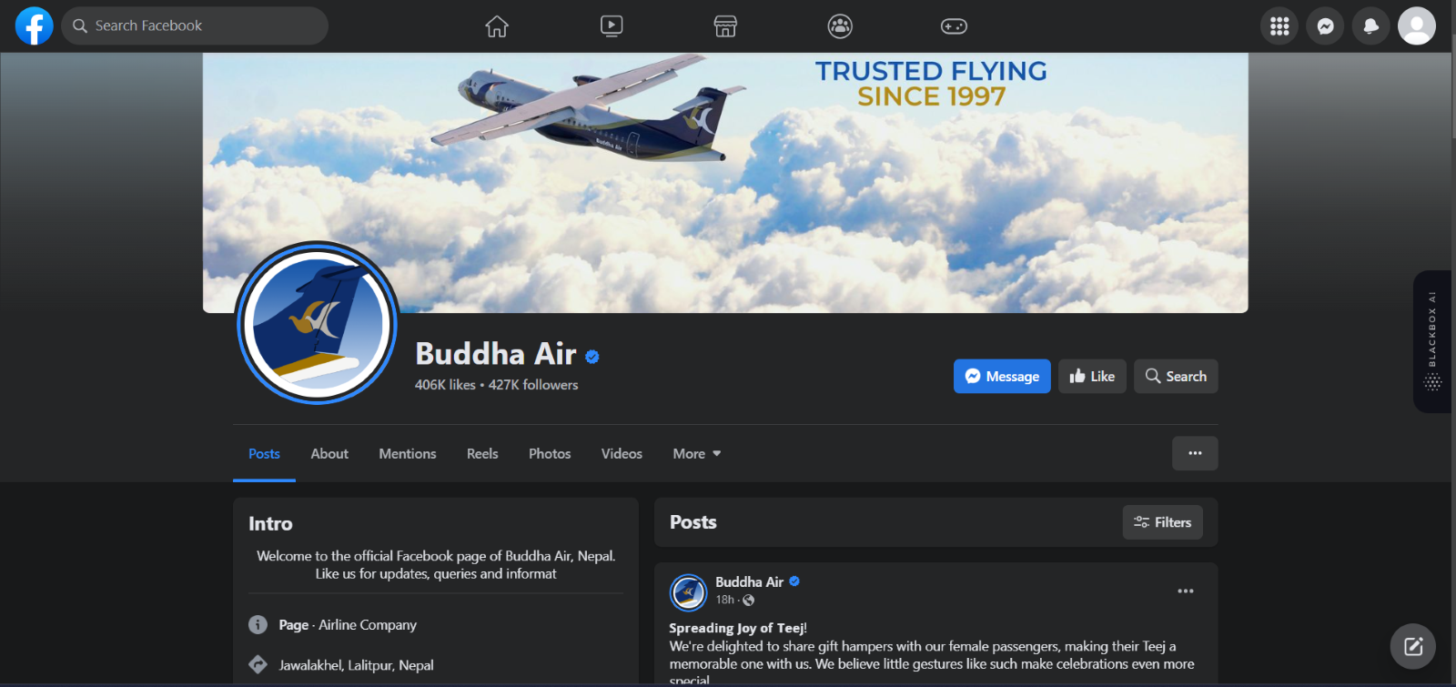
Figure 3: Buddha Air on Facebook
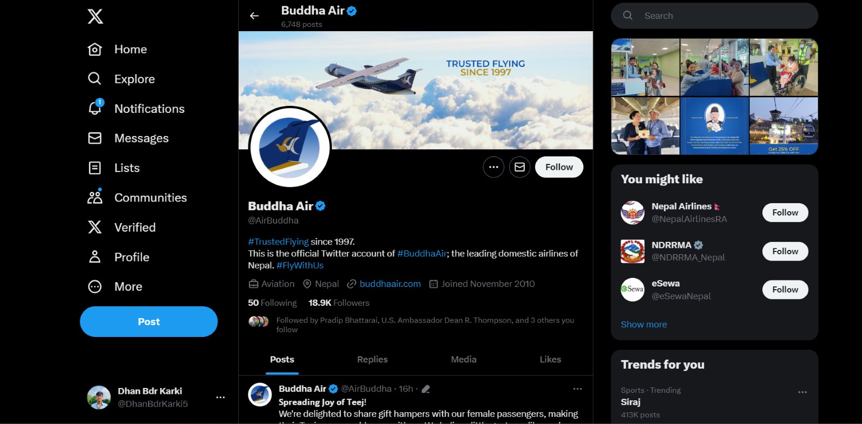
Figure 4: Buddha Air on Twitter
Buddha Air has over million of followers on different social sites and many posts per days. The team also uses the page for company news and announcements such as new flight routes, new services, awards, promotions, discounts to its loyal customers and travel tips. They also post and share Nepal’s scenery and behind-the-scenes photos and videos of Buddha Air’s operations, its employees, customers and the communities it serves. Twitter has been used to engage with customers and answer their questions. YouTube has been used to share educational video and aviation.
- Recommendations
Already evolving with two of the most important technology platforms to connect with its customer, Buddha Air is already on a good track. With a mobile application and being active on multiple social platforms improves the connection with their customer to a certain extent. This can further be improved with introduction of some new technological advancements to their existing system, below are the two recommendations that can further improve the connection between the customer and the company:

4.1 Personalized In-app Recommendations:
As the company has already developed a mobile app which offers a range of features including real-time updates and flight booking, a unique waw to further enhance the bond with their customer is by implementing personalized in-app recommendations. With the utilization of latest advancements in technology such as artificial intelligence and machine learning algorithms, it can be made possible so that the mobile app can analyze each customer’s travel history, preferences and behavior to provide more tailored suggestions and offers. This mechanism can be easily implemented by collecting data related to the customer’s past bookings, pattern of travel and preferred destinations. Further, these data can be analyzed to generate personalized travel recommendations with inclusion of suggestion regarding destinations, travel dates and special offers on preferred flights and accommodations.
Implementation of this technology can enhance the overall customer experience with valuable and customized suggestions which will increase the likelihood of repeat bookings and boost on supselling of service and revenue. The relatable in-app recommendations will encourage customers to spend more time within the app and strengthen the customer's connection with the company by differentiating the company’s app from competitors.

4.2 Gamify Online Engagement
As an organization already operating on both social platforms and mobile applications, the introduction of gamification can vastly change the amount of interaction on social platforms and applications both. The company can implement unique way of gamification strategy which involves interactions and engagement into a fun and rewarding experience for customers. This will include creating social media challenges, contests, or quizzes related to destinations and travel the company serves. Such discounts, loyalty points and other reward activities can encourage customers to participate and increase social interactions. The company can also include storytelling and user-generated content to enhance the gamification experience. This gamification implementation will help to create a sense of community and excitement among the customers which will strengthen their connection with the company.
As most of the population in today's era are active on the internet, presenting a significant opportunity for implementation of innovative customer engagement strategies like gamification. Gamification capitalizes on people’s love for online gaming, challenges, and rewards to enhance customer interactions. This approach can be a crucial addition to the company’s pool of strategies which will differentiate brand loyalty from competitors.

These recommendations will leverage the technology and innovative approaches to not only improve customer-company connections but also set the company apart from competitors. Personalized in-app recommendations offer a tailored experience, while gamifying online engagement adds an element of fun and rewards to customer interactions, creating more memorable and engaging customer journeys.

- Conclusion – 120-150

